Library Management System
–
Document ID: 0000.doc
Author(s): Preetha I
Version: 0.1
Date: April 2, 2024

1. Abstract 3
2. Objective and Scope 3
3. Project End Users 3
4. Module Description 4
4.1 Login to the system 4
4.2 Add/Edit/Delete Book 4
4.3 View Book 5
4.4 Issue Book 5
4.5 Return Book
5
5.Functional and Non-Functional Requirements 5
5.1 Functional Requirements 5
5.2 Non-Functional Requirements 6
6.High Level Design 6
7.Low Level Design 6
8.Diagrams 7
8.1 Use Case Diagram 7
8.2 Flow chart 8
8.3 Sequence Diagram 9
8.4 Class Diagram 10
9.ER Diagram………………………………………………………………………………………………………..11
10.Test Cases………………………………………………………………………………………………………..12

Abstract
The LMS comprises modules for adding, editing, and deleting books, alongside functionalities for viewing book details, issuing books, handling requests, and managing returns. Through the LMS, librarians can effortlessly catalog new additions, update existing records, and remove obsolete items, ensuring the accuracy and relevance of the library collection. User/Student benefit from user-friendly interfaces that enable them to explore the catalog, request books. The LMS also facilitates the smooth flow of book circulation, automating processes for issuing and returning items, thus reducing queues and wait times. Additionally, the system incorporates features for managing book requests. Security measures are integrated to protect patron privacy and prevent unauthorized access to library resource.

Objective and Scope
The objective and the scope of the project is to build a Library Management System that allow user to view the details of books, availability of the books and maximum time limit for borrowing.
The scope of the product includes the following basic features:
- Library staff members will have comprehensive access and control over the book inventory database, allowing them to execute various operations. They will possess the capability to remove outdated or irrelevant entries, update existing records with accurate information, and add new books.
- The application will record all books that are checked out, checked in, and recalled. This comprehensive recording system ensures that the status and whereabouts of each book are accurately tracked throughout its circulation within the library.
- By incorporating additional flexibility and convenience features, the library experience for users can be greatly enhanced. This could involve offering options such as extended borrowing periods, and remote access to digital resources.

Project End Users
- Admin/Librarians can efficiently manage book resources, including adding, editing, and deleting book records. Librarians can also oversee book circulation by issuing books to users and maintaining accurate inventory records, ensuring smooth operations.
- Students can easily view available books, request items for borrowing, and conveniently return borrowed books. This streamlined process ensures students have seamless access to the library's resources and promotes efficient circulation.

Module Description

Login to the system
Each and every user should be authenticated with a User Name and Password to login into the system.
Validations for User Name and Password.
User Name: It accepts only Alphabets, Numbers, Dot (.) symbol and Underscore (_) symbol.
Password: It can be anything of the users’ choice.

Add/Edit/Delete Book
Add Book:
Admins can easily add new books to the library's collection, enriching the inventory and catering to users' diverse interests.
Edit Book:
Admins have the authority to edit book details, ensuring accuracy and relevance in the catalog.
Delete Book:
Admins can able to delete outdated or irrelevant books from the system, maintaining a streamlined and up-to-date collection.

View Book
Both admins and users can conveniently access the complete list of books available in the library, enabling effortless browsing and exploration of available resources. This feature ensures transparency and accessibility, empowering users to make informed decisions about their reading choices. Administrators can utilize this function to oversee the library's inventory, while users can utilize it to discover new titles or locate specific books of interest.

Issue Book
Users can request books, and admins can fulfill these requests by issuing the requested books to the users, ensuring prompt access to desired resources. This process facilitates efficient management of borrowing transactions, enhancing user satisfaction by providing timely access to requested materials.

Return Book
User can return borrowed books and making the resources available for other users. This process ensures the efficient management of library resources.

Functional and Non-Functional Requirements

Functional Requirements
Login: Both admin and user can login to the system with corresponding username and password.
Add Book: Admin add new book to the system with necessary details like book id, name, author, etc.
Edit Book: Admin can edit the details of the book.
Delete Book: Admin can delete the outdated book from the system.
View Book: Both admin and user can view the book and search the book by its book id.
Request Book: User can request for the book.
Issue book: Admin can issue book to the user based on request made by the user. User can able view the issued book.
Return Book: User can return the book after completion.
Logout: Both admin and user log out from the system.

Non-Functional Requirements
The system shall support a minimum of 100 concurrent users without experiencing performance degradation. The system shall have a downtime of no more than 1 hour per month for maintenance purposes, scheduled during off-peak hours. Response time for administrative tasks such as adding, editing, or deleting books shall not exceed 5 seconds. The system shall be scalable to accommodate future growth in the number of users and library resources. The system shall be capable of handling large volumes of data efficiently, ensuring smooth performance during peak usage periods. The system shall adhere to industry-standard security protocols to protect user data and ensure data integrity while maintaining high performance.

High Level Design
The system will adopt a client-server architecture with web-based interfaces for users and administrators, facilitating seamless access to library services. User authentication will be ensured through secure mechanisms, with role-based access control governing system privileges. Backend services will operate as micro services, managing distinct functionalities such as manage book, requesting book, and user authentication. Database management will employ relational databases to store catalog information, user data, and transaction records, ensuring data integrity and scalability. Integration with existing library systems and third-party services will be seamless, enhancing interoperability and extending system capabilities. Continuous monitoring, logging, and security measures will be implemented to maintain system performance, reliability, and data protection.

Low Level Design
The UI will include components like search bars, buttons, and forms, implemented using front-end frameworks such as HTML, CSS and java script. CRUD operations for book management will be done in LMS, with schemas defining attributes like title, author, and availability status. Requesting book module will process reservation requests, querying the database for book availability and updating reservation statuses accordingly, ensuring efficient handling of user requests. Input validation and strict authentication protocols will be implemented to safeguard user data and prevent security breaches, ensuring robust system security.

Diagrams

Use Case Diagram
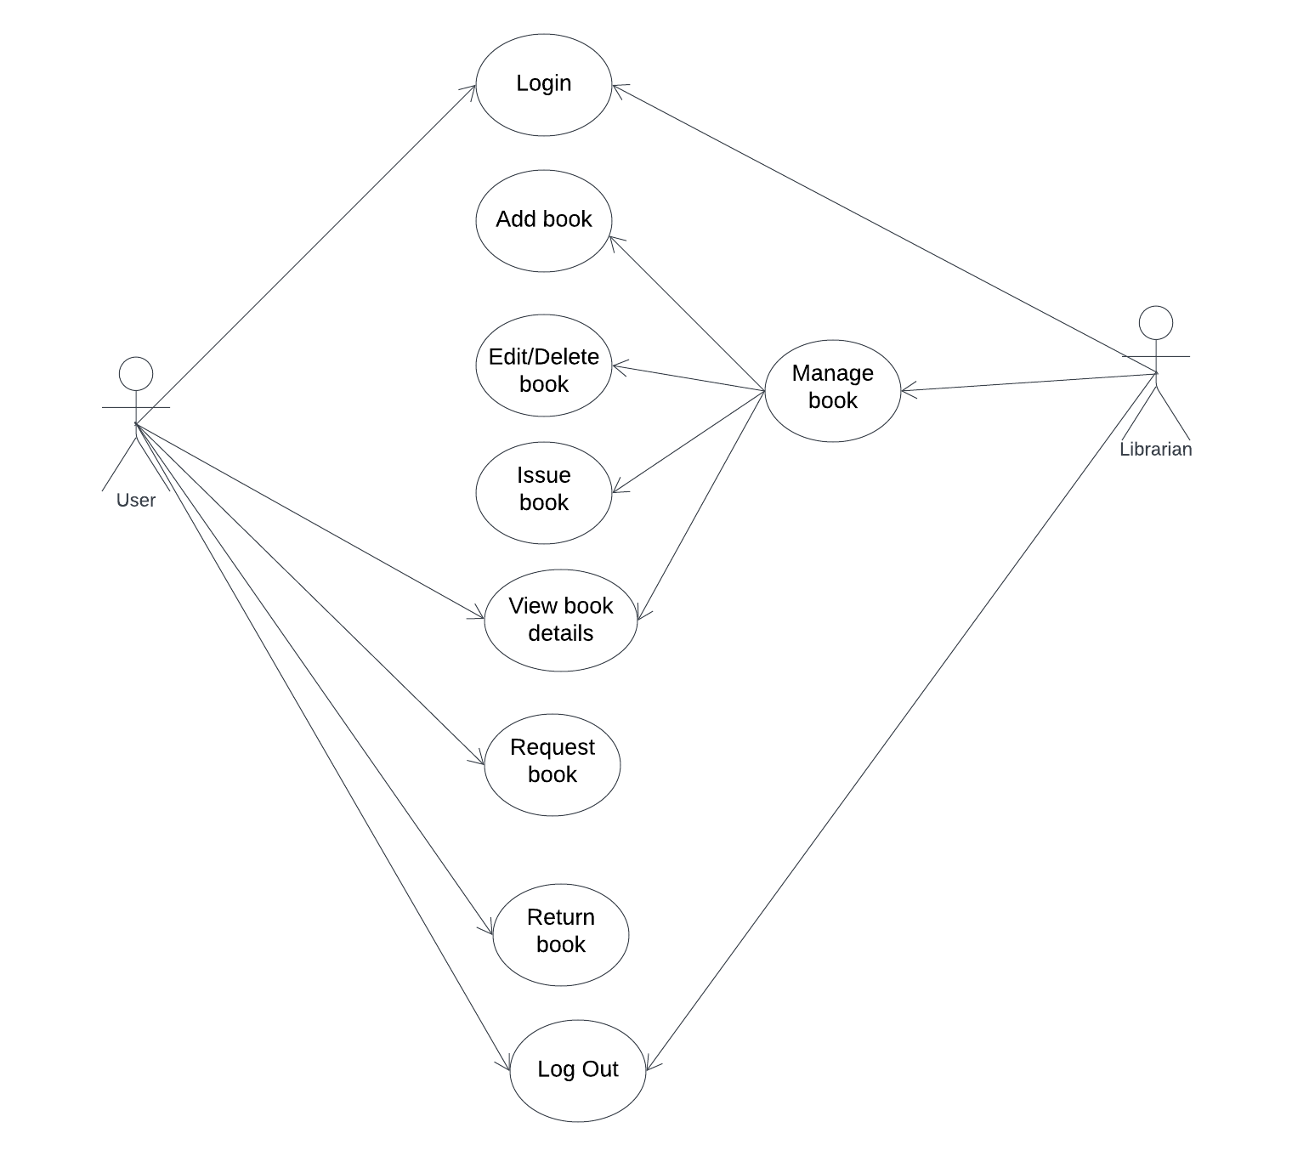

Flow Chart
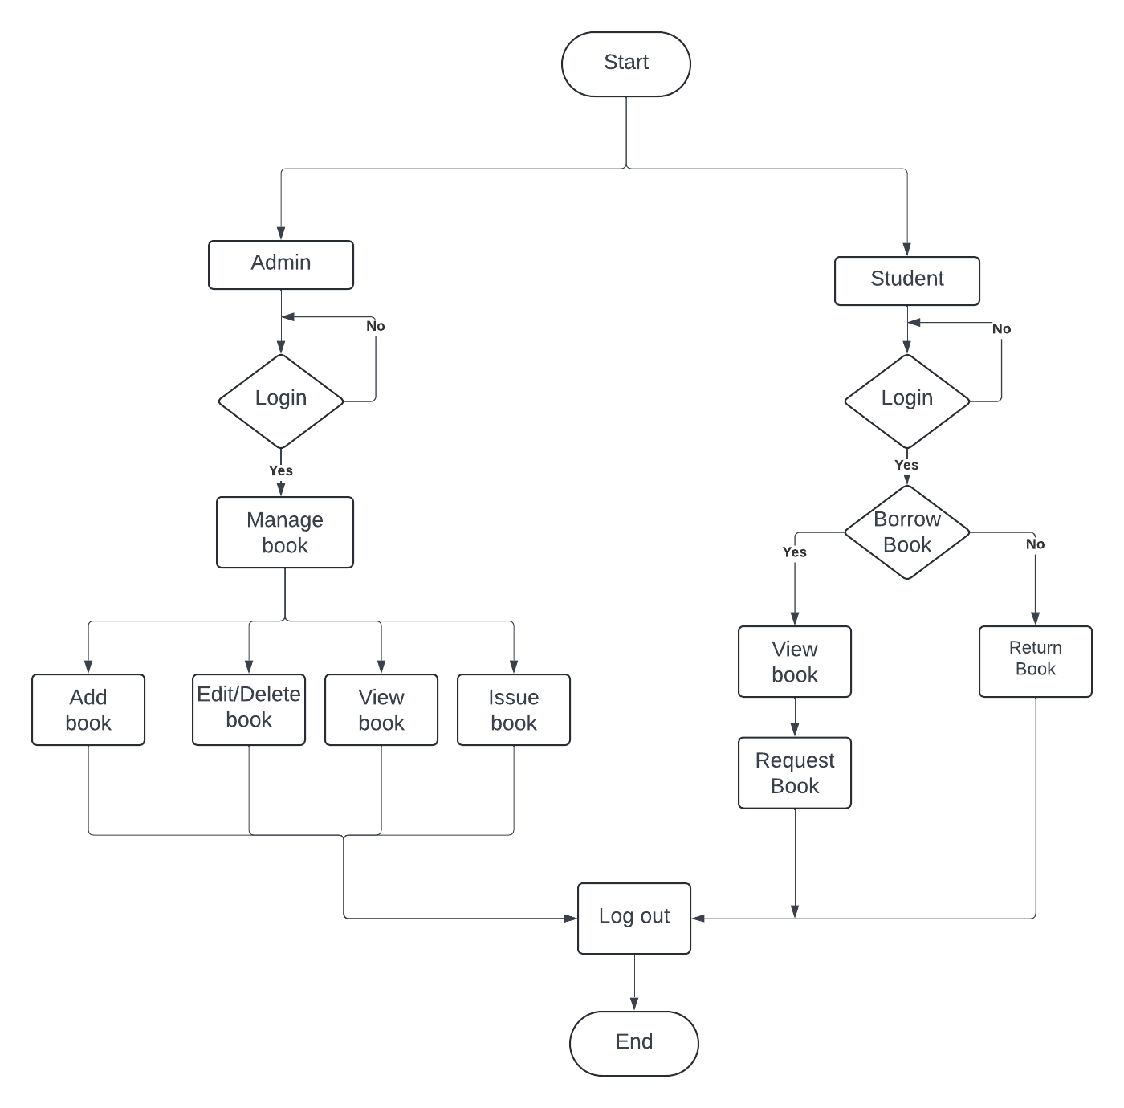

Sequence Diagram
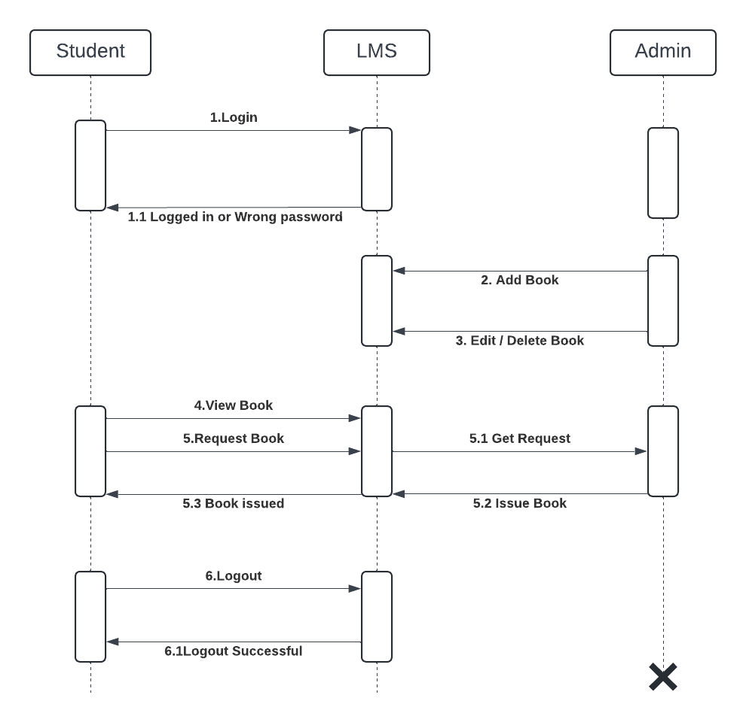

Class Diagram
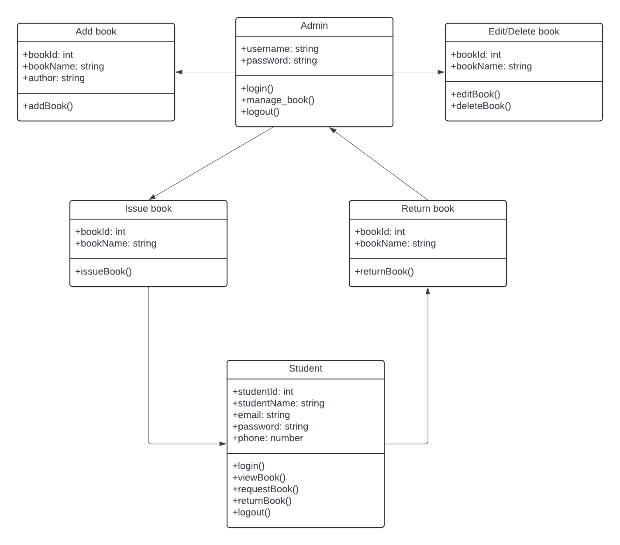

ER Diagram
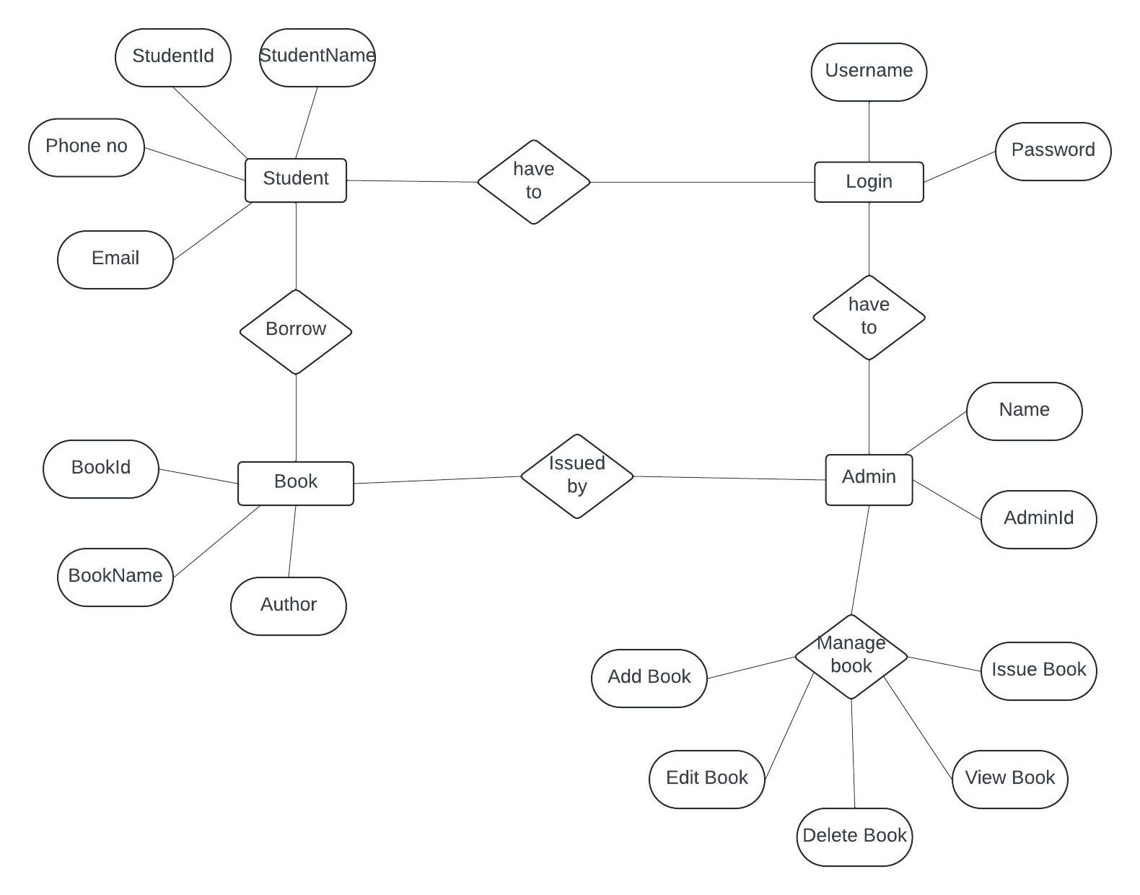

Test Cases
Test case | Test Purpose | Test condition | Expected outcome | Actual result
Admin login | Verify that the admin can login to the system successfully. | The username and password should be correctly entered. | Admin should able to login to the admin dashboard successfully. | If the username and password are correct, then the admin successfully entered to the dashboard.
Student login | Verify that the student can login to the system successfully. | The username and password should be correctly entered. If not, student have to register. | Student should able to login to the home page successfully. | If the username and password are correct, then the student successfully entered to the dashboard.
Add book | Verify that the book added to the database correctly. | The details like bookId, bookName, Author should be correctly entered. | It will successfully add a new book to the book database. | If the details are entered and submitted, then the new book is added.
Edit book | Verify that the details of the book is entered correctly. | Admin can able to the edit the book details. | The details of the book is updated successfully. | If the details are entered and submitted, then the book detail is updated successfully.
Delete book | Verify that the outdated book can be deleted successfully. | Admin can delete the outdated book from the database. | The outdated book should be deleted from the database. | The book is successfully deleted from the database.

